Title: **Wildlife Responses to Non-Motorized Recreation in the Southern Canadian Rockies: A Multi‑Scale Analysis near Fernie, BC**

Running head: **Fernie Rec Paper**

Clayton T. Lamb1,2*

Emily Chow3

**Affiliations**

1 University of British Columbia, Department of Biology, Kelowna, BC, Canada, V1V 1V7

2Wildlife Science Center, Biodiversity Pathways, Kelowna, BC, Canada, V1V 1V7

3Ministry of Water, Lands, and Resource Stewardship, Cranbrook, BC

*Corresponding author: clayton.lamb@ubc.ca

**Data availability**

The code and data to reproduce this analysis is deposited at the following github: <https://github.com/ctlamb/MtFernie_RecreationEcology>

The photos and species classifications from the Fernie Trail Network data are publicly accessible at the following links (each year of data is its own link):

<https://portal.wildtrax.ca/home/camera-deployments.html?sensorId=CAM&projectId=998>

<https://portal.wildtrax.ca/home/camera-deployments.html?sensorId=CAM&projectId=1401>

<https://portal.wildtrax.ca/home/camera-deployments.html?sensorId=CAM&projectId=1971>

<https://portal.wildtrax.ca/home/camera-deployments.html?sensorId=CAM&projectId=2626>

**Keywords:**

trail use, Ursus arctos, Cervus canadensis, camera trap, GPS telemetry, iSSA, non-motorized recreation, habitat selection, mountain bike, tourism

**Abstract**

Human outdoor recreation is expanding across natural landscapes, yet its effects on wildlife remain poorly understood across spatial and temporal scales and across different contexts. We assessed the responses of large mammals to non-motorized recreation near Fernie, British Columbia, Canada, using a multi-scale observational approach combining data from 66 camera traps and GPS telemetry from 21 grizzly bears (*Ursus arctos*). We evaluated (1) how wildlife detections varied by trail type, relative to the broader landscape, and with varying levels of recreational users, and (2) whether animals shifted activity to avoid peak human use, and (3) how collared grizzly bear movement responded to recreation compared to other anthropogenic features. Trail type, surrounding landscape, and recreational pressure significantly influenced detection probabilities, but responses varied by species and scales. Elk (*Cervus canadensis*) showed the strongest avoidance, with reduced presence on recreation trails (odds ratio ≈ 0.037, *p* ≈ 0.01) and a marked shift toward low-use periods (Δoverlap = –0.24). In contrast, moose (*Alces alces*) and mule deer (*Odocoileus hemionus*) were more frequently detected on or near recreation trails. Grizzly bears consistently avoided areas adjacent to recreation trails in GPS movement data and camera detections but were detected on recreation trails more than nearby wildlife trails suggesting when they do move through the trail network they do so on recreation trails. These findings highlight species- and scale-dependent behavioural responses, with effects ranging from strong (elk), to moderate (grizzly bears), to minimal (black bears, moose, mule deer, red fox, and white-tailed deer). Our results suggest that concentrating recreation near existing developed areas and during mid-day should minimize impacts on wildlife while providing important access to recreation for people. Maintaining low-use zones elsewhere will be important for more sensitive species. While observational studies like ours are valuable for identifying patterns and informing management of rapidly changing pressures, stronger inference through experimental designs is encouraged to clarify causal relationships between recreation and wildlife behavior and further elucidate species- and context- dependent relationships.

**Introduction**

Humans have long shaped the distribution, abundance, and behaviour of wildlife through habitat alteration and direct mortality. Road networks fragment habitat and cause vehicle collisions (Forman and Alexander 1998); human settlement and persecution has reduced or eliminated species from large portions of their former ranges (Laliberte and Ripple 2004). Yet despite these widespread impacts, people and wildlife have coexisted on Earth for millennia. Even under contemporary pressures, there remain landscapes—some densely populated by people—where large mammal communities persist with remarkable continuity (Laliberte and Ripple 2004). This contrast forms a central focus of conservation biology: sustaining wildlife in a modern world, and using the ecology of species to inform the expected response and potential mitigations to human impacts on wildlife.

Behavioural plasticity allows many species to adjust their activity or space use in response to human presence (Gaynor et al. 2025). For example, many large mammals shift to more nocturnal activity in areas of high human use (Gaynor et al. 2018, Lamb et al. 2020), or avoid high-risk areas altogether (Apps et al. 2004, Ciarniello et al. 2007, Prokopenko et al. 2017, Wyckoff et al. 2018). Other species show tolerance or habituation, and some even increase in abundance near people, as seen in generalist species such as rats, white-tailed deer, red fox, and coyotes (Breck et al. 2019, Tucker et al. 2021). Importantly, the same species can respond very differently depending on context. Elk, for instance, strongly avoid human footprint in relatively wild landscapes but may select for human-dominated areas such as agricultural fields or town edges when these provide forage or reduced predation risk (Wilmers and Levi 2013, Guthrie 2020, Gaynor et al. 2025). Grizzly bears often avoid busy highways, but may select for highway when their home ranges have low food availability and cleared roadsides provide relatively productive habitat (Palm et al. 2024). Mountain goats tend to avoid using areas disturbed by people regardless of the human footprint in their home range (Gaynor et al. 2025). Such examples underscore that animal responses to humans are shaped jointly by species identity and environmental context.

Just as wildlife depend on access to natural habitats, humans increasingly seek those same landscapes for health, well-being, and recreation. Time spent in nature has been linked to improved physical and mental health, enhanced cognitive function, and greater social cohesion (Bratman et al. 2019). Outdoor recreation often offers the dual benefits of time in nature paired with cardiovascular exercise (Thomsen et al. 2018). As participation in outdoor recreation grows (Outdoor Foundation 2025), so too does the spatial extent of recreational use—particularly in mountainous and forested regions. This expansion raises pressing questions about how human recreation influences wildlife, and how these landscapes can be stewarded to sustain both biodiversity and public access. Land managers, recreation planners, and policymakers are increasingly seeking science-based guidance to help anticipate, mitigate, or avoid unintended impacts on sensitive species (Miller et al. 2020, Jordan et al. 2025).

Recreation ecology—the study of recreational impacts on ecological systems—has expanded rapidly to meet this need (Monz et al. 2013). Yet its findings remain mixed. Some studies report strong negative effects of recreation on wildlife, such as spatial displacement, increased energy expenditure, reduced reproductive success, or elevated mortality risk (Wiedmann and Bleich 2014, Thompson et al. 2024, Urhan et al. 2025). Others document minimal or even positive responses, including behavioral habituation (Miller et al. 2020, Granados et al. 2023) or the use of human-modified areas as refuges for prey from predators or hunting pressure (Berger 2007). These variable responses tend to depend on species’ sensitivity, cumulative pressures from humans in the surrounding habitat, habitat quality, and the type, timing, and intensity of recreation (Naidoo and Burton 2020, Procko et al. 2022, Peters et al. 2025). This heterogeneity of outcomes poses a challenge for managers: the best available science is often context-dependent and difficult to generalize without appropriate consideration of species, landscape, activity type, and scale.

Among the most informative studies are those that employ experimental or quasi-experimental designs, such as before–after–control–impact (BACI) frameworks or manipulative trail closures. For example, Miller et al. (2020) conducted a BACI study around a new unpaved recreational trail being built in an Appalachian protected area, focusing on responses from white-tailed deer, coyotes, raccoons, and gray squirrels. Their results showed that overall species decreased use of the area during trail building but returned to baseline detection levels once construction was complete and humans were using the trail, albeit at low rates (1.4 visitors per day). Notably, control sites helped decouple population fluctuations from experimental effects that would have obscured results in even a traditional before-after experiment. Contrary to Millers results, Wiedmann and Bleich (2014) assessed bighorn sheep responses to a hiking trail built in western North Dakota, USA that had high rates of use. Although not stated in the paper, in 2016 the trail apparently was used by >15,000 users a year, or >40 people per day. They documented displacement, lower recruitment, population decline, and eventual abandonment of lambing areas in a subpopulation that lambed near the trail, where off-trail use was common. However, three other subpopulations of sheep were exposed to the trail at either lower intensities, more consistent human use, or at farther distances, and these populations showed no negative effects from the trail and increased in size. Experimental perturbations of elk and mule deer by recreationists at the Starkey Experimental Forest suggested recreationist displaced elk by >500 meters, reduced the time elk fed or rested, and increased the time they were travelling (Naylor et al. 2009, Wisdom et al. 2018). Recreation effects on elk were greatest from ATV riding, moderate from bikes, hikers, and horseback riders. Similar experiments on mule deer at Starkey Experimental Forest did not produce strong effects (Wisdom 2005). Even strong inference from experimental studies suggest recreational effects can and will vary by recreational type, intensity, predictability, and wildlife species.

Such context dependent responses to recreation are perhaps something that wildlife managers will have to accept, and thus the more information that can be generated on how these different contexts scale up to impact wildlife behaviour and demography at local and broader scales will allow for better evidence-based management. Importantly, experimental approaches can isolate causal effects but are logistically and ethically constrained, especially in high-use or multi-jurisdictional areas. As a result, well-designed observational studies remain an important part of knowledge generation, particularly when paired with complementary data sources such as telemetry or high-resolution camera monitoring.

Scale is also critical to recreation ecology inquiry. Johnson's (1980) hierarchical framework of habitat selection emphasizes that animals respond to their environment at multiple levels: the placement of home ranges within the landscape (second-order selection), the use of habitats within those home ranges (third order), and fine-scale behavioral decisions (fourth order). Recreational activity can influence wildlife at all these scales. Animals may avoid regions with high recreation altogether (Wiedmann and Bleich 2014), reduce use of areas near trails and infrastructure within their home range (Whittington et al. 2022, Thompson et al. 2024), or shift activity to less disturbed times of day (Gaynor et al. 2018, Lamb et al. 2020). As an example of scale-dependent effects,(. Accurately capturing such responses requires models and datasets that span both broad and fine spatial scales, and that are sensitive to variation in wildlife behaviour across space and time.

In this study, we examine how a community of large mammals responds to outdoor recreation in the southern Canadian Rockies near Fernie, British Columbia, Canada. We addressed four core questions: (1) Intensity of use: How do wildlife detections vary in areas of intense recreational use relative to the surrounding landscape and how do different levels of recreational use on trails influence detections? (2) Diel patterns: Do animals present in the trail network adjust the timing of their trail use to minimize overlap with recreational users and how does this compare to behaviour observed across the landscape? (3) Grizzly bear movement: How do GPS‑collared grizzly bears modify their movement and habitat selection in relation to trail proximity and recreation intensity? (4) Near encounters: How common are close encounters in space and time between humans and potentially dangerous animals such as bear, cougar, or moose on recreation trails? We hypothesized that if recreation was having strong and consistent negative effects then wildlife would be detected at lower rates in areas near trails due to animals avoiding the areas with high human disturbance. Within the trail network, we hypothesized that wildlife would select for wildlife trails with low human use, and that when selecting for human-made recreation trails, they would prefer trails with lower levels of human use. We hypothesized that wildlife would avoid the times of day when people are most active on recreation trails, and that this temporal avoidance would be weaker in areas with fewer people. We hypothesized that collared grizzly bears would strongly avoid the trail network, and this avoidance would be similar in magnitude to other high impact disturbances such as towns and the highway. Finally, we hypothesized that the overall avoidance of recreationists would mean there were few near encounters between recreationists and potentially dangerous wildlife. To answer these questions, we combined multi‑year camera‑trap monitoring with integrated step selection analysis of grizzly bear telemetry. This multi‑stream approach allowed us to assess patterns of avoidance, co‑use, and scale‑dependent sensitivity to recreation activity.

**Methods**

*Study Area*

We conducted our study in the forested mountain landscape surrounding Fernie, British Columbia, Canada (49.5°N, 115.1°W), a city of 6,320 residents as of the 2021 Census. Situated in the Elk Valley of southeastern British Columbia, Fernie lies along the Elk River and is encircled by the Rocky Mountains, including the Lizard Range and Three Sisters peaks (Figure 1). The region encompasses a broad elevation gradient (900–2,400 m) and features diverse forest types, including montane and subalpine coniferous stands dominated by Douglas-fir (*Pseudotsuga menziesii*), lodgepole pine (*Pinus contorta*), Engelmann spruce (*Picea engelmannii*), and subalpine fir (*Abies lasiocarpa*). Riparian zones along the Elk River and its tributaries support black cottonwood (*Populus trichocarpa*) communities.

Fernie is accessible via Highway 3 (Crowsnest Highway), a major east-west transportation corridor traversing southern British Columbia and connecting to Alberta through the Crowsnest Pass . The area supports a diverse assemblage of large mammals, including grizzly bears (*Ursus arctos*), black bears (*U. americanus*), cougars (*Puma concolor*), wolves (*Canis lupus*), elk (*Cervus canadensis*), and mule and white-tailed deer (*Odocoileus spp.*). A dense, year-round network of recreational trails—used by hikers, bikers, backcountry skiers, and motorized users—overlays this habitat, primarily on provincial Crown land but also on private land accessible to the public.

*Camera Traps*

We deployed remote cameras (Reconyx Hyperfire 2) throughout the recreational (Rec) trail network on Mount Fernie and Mount Proctor (hereafter collectively called Mount Fernie trail network) (Figure 1). Cameras were set on a tree 1.5 meters above the ground and 6-10 meters from the trail. Any vegetation that would interfere with detection on the trail was removed each year in the spring or summer. We sought to keep cameras >150 m apart to reduce spatial autocorrelation.

We monitored human and wildlife use on two types of trails, 1) single and double track bike and hiking trails (together called Recreation trails, n=18) , and 2) adjacent wildlife trails within 500 meters of trails (n=10). Cameras were programmed to take 5 photos at each detection on high sensitivity, with <1 second (rapid-fire setting) between images. No delay between subsequent detections were set, essentially meaning the camera took as many photos as fast as it could while there was detectable movement in its’ view. A timelapse photo was set to be taken at 12:00 pm daily to denote the period the camera was operating. The cameras were checked 2-10 times a year and were present year-round from May 2021- November 2024.

We uploaded images to WildTrax (https://wildtrax.ca/), a cloud-based camera trap data management platform. The MegaDetector software (Beery et al. 2019) is automatically run within WildTrax to flag images containing animals, humans, or vehicles, and to remove high-likelihood empty images, thereby increasing the efficiency of downstream processing (Fennell et al. 2022). A team of image taggers from the Alberta Biodiversity Monitoring Institute manually verified species tags in each image and classified images without species tags from the MegaDetector. For each image the number of each wildlife species present in the image was recorded. We did not count the number of humans present in each image due to the volume of photos, and rather just tagged to the type of human use- bike, vehicle, off-road vehicle, heavy machinery, or human (typically a hiker or runner). Initially we classified domestic dogs along with hikers and bikers on the trails. Dogs were present at high rates, and we didn’t expect that there would be sufficient variation in dog absence or presence with recreationists to assess dog effects, thus we stopped tagging dogs in 2022 to reduce costs and do not conduct any analyses on domestic dogs. Off leash dogs were common.

In addition to the camera traps specifically deployed for this project, we also used cameras from neighbouring projects near Fernie to gain a broader landscape perspective (Figure 1). These cameras were dispersed through the Elk and adjacent river valleys as well as high elevation areas. While these cameras were deployed on a variety of trail types, we only used the cameras deployed on wildlife trails. We broke these landscape-level cameras into two groups. The “landscape-valley” group was within 25 km of Fernie and in similar habitats to the Fernie recreation cameras (n=21), which were typically Interior Cedar Hemlock or Montane Spruce zones. The landscape-valley cameras were in areas that also had highways, railways, towns, and resource roads but less recreational use than the Fernie trail network and thus provided a comparison with insight into the additive effect of the trail network on wildlife detections and behaviour. The second group, “landscape-remote”, were in more remote and higher elevation habitats than the Fernie trail network (n=17). Because the habitat of the landscape-remote cameras was not as comparable with the Fernie trail network we used these cameras for temporal (diel) comparisons only but not intensity of use. All cameras were the same brand (Reconyx), although a variety of Reconyx models were used (HP2X, Hyperfire PC600-900). We included the camera model in our models to account for detectability differences. Details on these landscape-level camera projects can be found in the following publications (Granados et al. 2023, Lamb 2025a, 2025b, Lamb et al. 2025), (Figure 1).

*Camera Statistical Analysis*

From the classified images, we created several datasets for the following analyses. We subset the camera data to the period between May 1 and October 31 each year to focus on the snow-free season, when wildlife were consistently present across the landscape. This period also corresponded with peak non-motorized recreational activity on the Fernie trail network*.* During the winter months many migratory ungulates left the area and bears were hibernating (Lamb et al. 2022, Poole et al. 2024). Recreation use was low in winter on most trails except those groomed for winter biking, walking, or cross-country skiing. We considered an alpha level of 0.10 for statistical analyses of the camera data due to small sample sizes.

*Intensity of use*—We generated a detection dataset by collapsing consecutive photos of the same species into single detection events if separated by less than ten minutes. This approach likely underestimates the true number of recreationists detected as many individuals or groups may pass in 10-minute window but aligns with the tagging protocol of the landscape-level cameras allowing for comparison among projects. These detections were compiled for each species at each camera. We assessed how average monthly detection rates varied by location (Recreation trails and wildlife trails in the Fernie trail network and the Landscape-valley cameras outside the Fernie trail network) using generalized linear mixed models. We fit these models using the glmmTMB package in R (Brooks et al. 2017). To account for the abundance of months with no detections, we used a hurdle-model approach where we first modelled presence-absence using a binomial model with logit link for each species per month and then a second model where animals were detected using a truncated Poisson distribution to model the frequency of detections. For each model we included random intercepts for camera model, month, year, and camera ID. We also assessed if additional environmental variables were appropriate to include to remove environmental variation between the camera projects that could interfere with our comparisons. For each species we compared whether inclusion of indices of habitat productivity (annual precipitation or summer enhanced vegetation index) improved the fit of data to the model via Akaikes Information Criteria (AIC, Akaike (1973)) . In cases where these covariates improved model fit, we included the covariates in their final model. For each species, we evaluated the detection rate model for spatial autocorrelation using Moran’s I in the *spdep* package (Bivand 2022), and assessed overdispersion using simulation-based dispersion tests implemented in the *DHARMa* package (Hartig 2024). To visualize expected monthly detection rates, we generated predictions for a ‘typical’ camera-month (HP2X model, July 2024, 30 trap-nights) at average environmental covariate values. Because the same random-effects combination was used for all trail types, comparisons among trail types reflect fixed-effect differences rather than specific site conditions.

Within the Fernie trail network, we used the camera data to assess how wildlife detection rates were influenced by the detection rate of recreational users on the recreation trails. We conducted this analysis at a weekly interval to detect finer-scale responses of wildlife to changing recreation pressure. To account for finer differences between trail locations we included measures of canopy cover, slope, summer enhanced vegetation index, and distance to a building for each camera. We used the hurdle model structure as above to model presence and then detection frequency based on the number of recreational users on the trails. We included random effects for week of the year, year, and camera ID. No random effect for camera model was included because the cameras were all the same model in this analysis.

*Diel patterns–*In addition to comparing detection rates across space, we analyzed temporal variation in response to human recreation by summarizing daily diel overlap between people and wildlife across trail types. We assessed diel patterns using detection histograms and calculated coefficients of temporal overlap (Δ) to quantify behavioral displacement of wildlife from people on recreation trails, adjacent wildlife trails, and the wildlife trails across the broader landscape. Because human detections were concentrated on recreation trails, we used the peak human-use periods on these trails as a reference. We then tested whether wildlife on adjacent wildlife trails or elsewhere in the landscape also reduced their activity during these peak times, despite not experiencing the same level of human pressure.

*Near encounters–*To quantify how often large mammals were detected soon before or after recreationists, we paired every biker and hiker detection on single-track trails with all detections of black bears, grizzly bears, cougars, wolves, or moose at the same camera. We selected these animals as they are the primary species that can be dangerous to people and were frequently or occasionally detected in the trail network. We then kept only the closest-in-time wildlife detection for each species and recreation event. We calculated the time difference in minutes and summarized how often wildlife detections occurred within 30 minutes and within 5 minutes of people. We also assessed near encounters with recreationists from the wildlife’s perspective to determine how often wildlife had near encounters with recreationists.

*Collared Grizzly Bears*

Grizzly bears were collared throughout the Elk Valley between 2016-2024 as part of a study to assess population demography (Lamb et al. 2023). Although the study goal was not to assess recreational impacts on bear behaviour, we are able to leverage these data as part of our multi-lines of inference approach given the abundance of grizzly bear telemetry around Fernie. Full details on the grizzly bear capture and handling and relevant permits are summarized in (Lamb et al. 2023). Briefly, the bears we considered here were collared with Vectronics Vertex Lite GPS collars programmed to take locations every 2 hours during the active season for grizzly bears (April to December). The data was transmitted via Iridium satellite. We collared all age and sex classes except animals <2 years of age due to challenges fitting collars to these rapidly growing young bears. For this analysis we used location data for bears with at least 50 locations within 10 km of Fernie between May 1-October 31 across years.

*Grizzly Bear Integrated Step Selection Analysis*

We used integrated step selection analysis (iSSA) to evaluate how large mammals respond to human recreation and habitat features in the Fernie region of British Columbia (Avgar et al. 2016). Step selection functions were implemented using conditional Poisson regression with random effects, which is mathematically equivalent to conditional logistic regression but enables more flexible estimation of random slopes and intercepts using generalized linear mixed models (GLMMs) (Muff et al. 2020).

For each GPS-collared animal, observed steps were paired with a set of ten random available steps drawn from the empirical step length and turn angle distribution, forming matched strata of one “used” and ten “available” steps. We then fit iSSA models using the glmmTMB package (v1.1.7) in R, with a binary response variable (where 1 = used step and 0 = available), family = poisson, and a random intercept for each stratum to condition the analysis within each matched set.

The fixed effect’s structure included habitat covariates (e.g., land cover type, elevation, summer greenness [EVI]), topographic complexity (TRI), and several measures of anthropogenic influence, including distance to trail, highway, and rural development, as well as semipermeable barrier effects. Movement covariates included step length (log-transformed), turn angle (cosine), and their interaction (e.g., cos_ta:log_sl_km) to capture behavioral state transitions. We also included habitat-by-movement interactions (e.g., cos_ta:dist_to_trail) to allow for context-dependent movement decisions.

To account for variation in selection across individuals and seasons, we included random slopes by individual (0 + covariate | id) for key habitat, movement, and barrier variables, and a random slope for elevation by month to account for seasonal effects (0 + elevation_end | month). All continuous covariates were standardized prior to modeling to facilitate convergence and comparability of coefficients.

We used a candidate model approach to evaluate how outdoor recreation and environmental covariates influenced step selection by wildlife. We began with a core set of ecological and movement covariates and iteratively added disturbance and barrier terms to construct biologically plausible models. Each candidate model was evaluated using AIC and the top model was selected based on parsimony and fit.

To assess model stability and performance, we examined predicted values to ensure no extreme or implausible outputs and checked for convergence warnings. Due to the structure of iSSA data—particularly the large number of strata and design-imposed zeros—we did not use residual simulation tools such as DHARMa, which are known to perform poorly under these conditions.

**Results**

*Camera Traps*

Cameras operated in the Fernie trail network for 13, 698 trap nights between May 1, 2021, and October 31, 2024, and captured 1,739,387 images. After removing empty images and classifying unique detections (images 10 minutes apart) there were 98,499 detections. Of these detections, 88,558 were of people, 43 of domestic species, and 9,451 were of wildlife (Table 1). Mountain bikers were the most detected recreational group on the cameras. White-tailed and mule deer were the most detected wildlife. Several species were detected at low rates (<30 detections) such as bobcats, badgers, wolverine, and a mountain goat and were not used in subsequent analyses due to their rarity. We focus our analyses on 7 large/medium mammal species with > 30 detections each (white-tailed deer, mule deer, elk, red fox, moose, black bear, and grizzly bear).

Most cameras were placed at least 150 m apart, with five exceptions. Four pairs of wildlife‐trail cameras ended up <150 m apart: in two cases the original tree fell and the camera was reinstalled nearby under a new name, and in two cases we added an additional camera after deployment upon identifying more actively used wildlife trails in close proximity. One pair of recreation‐trail cameras was 90 m apart because the trails paralleled each other. We evaluated potential spatial autocorrelation in Supplementary Data S1. Only elk showed statistically significant autocorrelation, but the effect was extremely small (r = 0.01) and not biologically meaningful. Given that 8 of 9 species showed no detectable autocorrelation and the elk effect was negligible, we retained all cameras in the analysis.

Table 1. Summary of detections by species at Fernie Trail Network cameras between May and October each year between 2021-2024.

|  |  |  |  |  |  |
| --- | --- | --- | --- | --- | --- |
| **Group** | **Species** | **Sites** | **Detections** | **Hit rate per 100 days** | |
| Human | bike | 19 | 73346 | 535.5 |
| Human | human | 28 | 14666 | 107.1 |
| Human | all terrain vehicle | 8 | 286 | 2.1 |
| Human | vehicle | 5 | 242 | 1.8 |
| Human | heavy equipment | 2 | 18 | 0.1 |
| Wild | white-tailed deer | 28 | 3611 | 32.6 |
| Wild | mule deer | 27 | 2008 | 17.9 |
| Wild | elk | 27 | 1382 | 13.4 |
| Wild | red fox | 22 | 908 | 6.7 |
| Wild | moose | 26 | 670 | 5.7 |
| Wild | black bear | 28 | 464 | 3.8 |
| Wild | Deer sp. | 24 | 141 | 1.1 |
| Wild | grizzly bear | 20 | 101 | 1 |
| Wild | snowshoe hare | 7 | 85 | 0.6 |
| Wild | gray wolf | 11 | 22 | 0.2 |
| Wild | cougar | 9 | 14 | 0.1 |
| Wild | bird | 9 | 13 | 0.1 |
| Wild | coyote | 8 | 10 | 0.1 |
| Wild | porcupine | 6 | 7 | 0.1 |

*Camera Statistical Analysis*

*Intensity of use*— We evaluated dispersion in detection models to determine whether the Poisson distribution was appropriate (Supplementary Data S2). Overall, we found little evidence of overdispersion. Elk showed the highest dispersion (ratio = 2.6), indicating greater variance than expected, but this was not statistically significant. Black bear exhibited a near-significant test (p = 0.056) but only modest dispersion (ratio = 1.6). All other species showed no indication of overdispersion. Based on these results, we retained the Poisson distribution for all models.

Across species, trail type and surrounding habitat influenced detection probabilities and detection frequency, but effects varied by species and by model component (presence vs. frequency). Trail contrasts were assessed both between the Mt. Fernie trail network and the broader valley, and within the trail network (wildlife vs. recreation trails, Figure 2).

Humans and bikers were overwhelmingly detected on recreation trails. Relative to Landscape-valley cameras, humans were far more likely to be detected within the Mt. Fernie trail network: the odds of at least one monthly human detection were ~124 times higher in the trail network (OR ≈ 124, p < 0.001), and expected monthly detection frequency in areas that bikers were present were ~22 times higher (ratio ≈ 22, p ≈ 0.008). Within the Mt. Fernie network, humans were strongly concentrated on recreation trails, with ~613-fold higher odds of detection (OR ≈ 613, p < 0.001) and ~59-fold higher detection frequency (ratio ≈ 59, p < 0.001) on recreation versus wildlife trails. Biker detections showed an even more extreme pattern, with almost no detections in the Landscape-valley or on wildlife trails; presence contrasts indicated orders-of-magnitude higher odds of biker detections on recreation trails, though some frequency contrasts were unstable because of near-zero counts in the valley.

Black bear presence was higher within the Mt. Fernie trail network than at Landscape-valley sites (OR ≈ 2.8 in favour of the trail network, p ≈ 0.047), and bears were especially likely to occur on wildlife trails compared to Landscape-valley cameras (OR ≈ 3.7, p ≈ 0.032). No difference between wildlife trails and recreation trails were detected within the Mt. Fernie network. Detection frequency, conditional on presence, did not differ significantly among trail types for black bears.

Elk showed the opposite broad-scale pattern. Elk were much more likely to be detected at Landscape-valley sites than within the Mt. Fernie trail network (OR ≈ 36.7 in favour of the Landscape-valley, p ≈ 0.005), and also more likely at Landscape-valley sites than on wildlife trails (OR ≈ 22.7, p ≈ 0.019). Within the trail network, elk were more likely to occur on wildlife trails than recreation trails (OR ≈ 2.6, p ≈ 0.065), consistent with the low elk detections on recreation trails. Detection frequency contrasts for elk were not statistically supported.

Grizzly bears were detected infrequently, but there was some evidence of trail-type effects. At the broad scale, models suggested that grizzly bears were more likely to occur in the Landscape-valley than in the Mt. Fernie trail network (OR ≈ 2.2 in favour of the Landscape-valley, p ≈ 0.08), and that detection frequency was also higher in the Landscape-valley (ratio ≈ 2.2, p ≈ 0.10), although both effects were uncertain. Within the Mt. Fernie network, grizzly bear presence was higher on recreation trails than wildlife trails (OR ≈ 4.6 in favour of recreation trails, p ≈ 0.002), while detection frequency remained similar.

Moose showed a strong contrast in presence, but not in detection frequency. Moose were far more likely to be detected within the Mt. Fernie trail network than at Landscape-valley sites: the odds of detection were ~80 times higher in the trail network (OR ≈ 80, p < 0.001), and ~54 times higher on wildlife trails than on Landscape-valley cameras (OR ≈ 54, p < 0.001). Differences in detection frequency were poorly estimated because moose were almost never detected at Landscape-valley sites, and frequency contrasts were not statistically significant.

Mule deer generally followed a similar pattern to moose at the trail-network scale, but with weaker effects. There was suggestive evidence that monthly detection frequency was higher within the Mt. Fernie trail network than at Landscape-valley sites (ratio ≈ 1.9 in favour of the trail network, p ≈ 0.08). Within the trail network, mule deer were more likely to occur on recreation trails than wildlife trails (OR ≈ 3.3, p ≈ 0.013), and showed marginally higher detection frequency on recreation trails (ratio ≈ 1.8, p ≈ 0.08).

Red foxes were strongly associated with the Mt. Fernie trail network. Foxes were substantially more likely to occur within the trail network than at Landscape-valley sites (OR ≈ 8.9 in favour of the trail network, p ≈ 0.013). Within the network, foxes tended to be more common on recreation trails than wildlife trails: the odds of detection were ~3.7 times higher on recreation trails (OR ≈ 3.7, p ≈ 0.065), and detection frequency was ~5.5 times higher (ratio ≈ 5.5, p ≈ 0.004).

White-tailed deer showed relatively similar detection rates across trail types. Although point estimates suggested somewhat higher detections in the Mt. Fernie trail network than in the Landscape-valley, none of the presence or detection-frequency contrasts for white-tailed deer were statistically significant (all p > 0.1). Cougars and gray wolves were rarely detected, and models for these species were unstable; we therefore excluded them from subsequent analyses.

Species varied in their responses to local recreation activity on single-track trails, but the strength and direction of effects differed by species and model component (presence vs. detection frequency, Figure 3). Elk showed the strongest evidence of recreation avoidance: both the probability of occurrence (β ≈ −0.37, p ≈ 0.002) and expected detection frequency (β ≈ −0.15, p ≈ 0.038) declined significantly with higher recreation use — a stronger effect than any local habitat variable in the model.

In contrast, mule deer and moose showed positive associations with recreation activity. Mule deer were more frequently detected in areas with greater recreation use, with positive effects on both presence (β ≈ 0.25, p ≈ 0.069) and detection frequency (β ≈ 0.14, p ≈ 0.036), although these effects were moderate in size. Moose also showed a significant increase in detection frequency with higher recreation levels (β ≈ +0.32, p ≈ 0.009), but presence was not significantly affected (β ≈ +0.11, p = 0.48).

Red fox, black bear, white-tailed deer, and grizzly bear showed no clear relationship with local recreation levels. For these species, both presence and detection frequency estimates were small and statistically non-significant (p > 0.1), indicating little to no consistent response to trail use intensity.

*Diel patterns—* Hikers and bikers were active almost entirely during daylight hours on single-track trails, with detections peaking from about 9 AM to 8 PM. All wildlife species showed strongly crepuscular or nocturnal activity overall, with lower detections during these core human-use periods.

The overlap estimates reflect how closely each wildlife species’ daily activity on recreation trails, wildlife trails, landscape-valley, and landscape-remote coincides with the peak periods of recreation use on recreation trails, hereafter called the recreation period (Figure 4). In this analysis we incorporate the Landscape-remote cameras, which capture animal behaviour in higher elevation areas with much lower human pressure than the other areas and perhaps serve as a comparison for behavior that is less impacted by people. Black bears had moderately lower diel overlap with recreation periods on recreation trails (mean ≈ 0.62) than on adjacent wildlife trails (0.74; Δ = –0.13, *p* < 0.10). However, overlap did not differ significantly between recreation trails and landscape-valley or landscape-remote sites. Elk exhibited clear diel avoidance: overlap on recreation trails (0.28) was significantly lower than on adjacent wildlife trails (0.40), landscape-valley sites (0.31), and especially landscape-remote sites (0.51). The greatest contrast was between recreation trails and landscape-remote sites (Δ ≈ –0.24, *p* < 0.10), indicating strong temporal shifts away from human-dominated periods on busy trails. Grizzly bears showed moderate diel differences, with significantly lower overlap on recreation trails (0.44) than in landscape-remote areas (0.62; Δ ≈ –0.15, *p* < 0.10). Overlap on recreation trails vs. landscape-valley sites was slightly higher (Δ ≈ 0.12) but not statistically significant, and no estimate was available for wildlife trails due to too few detections.

Moose showed minimal diel variation across contexts. Overlap estimates ranged from 0.43 (recreation trail) to 0.50 (landscape-remote), with only a small difference between recreation trails and remote sites (Δ ≈ –0.07, *p* < 0.10), suggesting modest temporal avoidance of peak human use. Mule deer had broadly consistent overlap across locations but showed significantly lower overlap at landscape-remote sites (0.44) compared to recreation trails (0.51; Δ ≈ -0.09, *p* < 0.10). Slight differences from recreation to wildlife trails (Δ ≈ –0.03) or landscape-valley (Δ ≈ –0.01) were not significant.

Red foxes exhibited the strongest diel shift: overlap was much lower on recreation trails (0.18) than on wildlife trails (0.41; Δ ≈ –0.25, *p* < 0.10) and valley sites (0.41; Δ ≈ –0.23, *p* < 0.10), consistent with strong temporal avoidance of human activity in high-use areas. Comparisons with landscape-remote sites were not possible due to too few detections. White-tailed deer showed slightly lower diel overlap in landscape-valley and remote contexts (≈0.40–0.44) compared to recreation trails (0.53), with significantly higher overlap on recreation trails vs. landscape-valley (Δ ≈ 0.13, *p* < 0.10) and vs. landscape-remote sites (Δ ≈ 0.08, *p* < 0.10). This pattern suggests a tolerance of daytime human activity.

*Near encounters–* Across all recreation trail detections, only a small fraction of recreation events were associated with close-in-time wildlife detections. For black bears and moose, about 0.1% of recreation events had a wildlife detection within 30 minutes (151 and 153 cases respectively), and around 0.02% fell within just 5 minutes (20 and 26 cases respectively). Grizzly bears showed lower overlap, with only 0.011% of recreation events within 30 minutes (14 cases) and none within 5 minutes. Overall detections of cougars and wolves were low on recreation trails, and mostly at occurred at night. Of the recreationist detections, three events (0.003%) had a cougar detection within 30 minutes, and two events (0.002%) fell within just 5 minutes of a cougar. Wolves were only detected >30 minutes from recreationists. Histograms show that most close calls were distributed throughout the 0-30 minute period considered, with no strong bias toward bikers or hikers for any species (Figure 5).

Although recreationists were unlikely to encounter dangerous wildlife—both because recreationists were numerous (diluting per-capita risk) and because some species avoided the trail network—wildlife themselves were more likely to encounter a recreationist. We recorded 304 black bear detections on recreation trails; 24% of these (n = 72) occurred within 30 minutes of a recreationist, and 6% (n = 18) occurred within 5 minutes. Moose were detected 563 times, with 14% (n = 79) within 30 minutes and 4% (n = 23) within 5 minutes. Grizzly bears were detected 94 times, 10% (n = 9) of which were within 30 minutes of a recreationist. Cougars were detected 30 times, with 10% (n = 3) within 30 minutes and 7% (n = 2) within 5 minutes. In many cases, multiple recreationists were detected in the minutes surrounding each wildlife event, indicating that “close calls” were often followed by more close calls, not restricted to solitary encounters.

*Collared Grizzly Bears*

After sub-setting to the focal area around Fernie and the desired seasonal window we retained 19,489 GPS collar locations from 21 grizzly bears between June 2017 and October 2024. An average of 928 locations per bear were collected within the focal area, which ranged from 61-3,012 locations across all 21 bears.

*Grizzly Bear Integrated Step Selection Analysis*

A suite of candidate iSSA models was compared using AIC to evaluate drivers of wildlife movement. The best-supported model included trail distance, town distance, and highway effects (AIC = 394,212), outperforming all alternatives by ≥34 AIC units. This suggests that the combined influence of multiple anthropogenic features best explains movement behavior, with trails emerging as particularly influential (Figure 6).

Among fixed effects, animals selected areas with higher summer greenness (EVI β = 0.44, *p* < 0.001) and avoided steep elevation gains (Δelev β = –0.37, *p* < 0.001). Distance to trails significantly increased selection (β = 0.088, *p* = 0.016), indicating avoidance of trail-adjacent areas. Crossing trails further reduced selection (β = –0.23, *p* < 0.001), an effect of smaller magnitude to barrier effects from highways (β = –0.50) and rivers (β = –0.68). Trail-related avoidance was notable but generally weaker than town and highway effects. Step–trail interactions revealed that animals took longer steps when closer to trails (β = –0.044, *p* < 0.001), suggesting faster movement near recreation infrastructure. Random slopes revealed substantial individual variation, particularly for barrier responses.

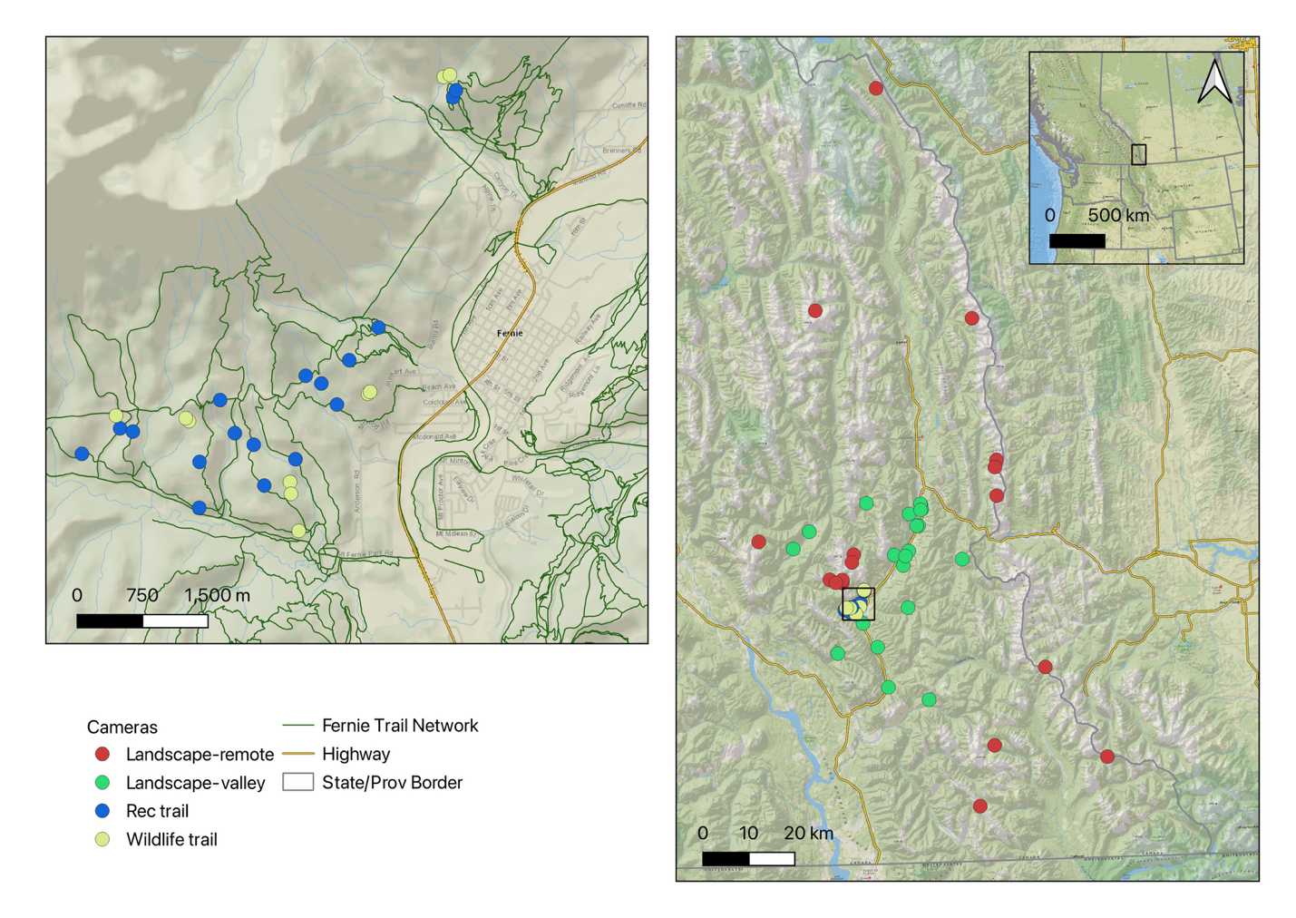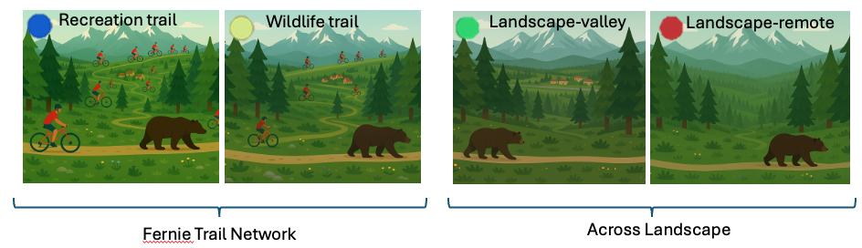

Figure 1. Map of study area near Fernie, BC, Canada in the southern Canadian Rockies. The Fernie trail network was assessed west and north of Fernie BC on the slopes of Mount Fernie and Mount Proctor with cameras on wildlife trails and recreation trails. Landscape-level comparisons across these habitat contexts were made with ancillary data from neighboring camera projects where landscape-valley were in similar habitats and a multi-use landscape to the Fernie trail network cameras but with less overall non-motorized recreation pressure. Landscape-remote were on wildlife trails in areas with lower levels of human pressures compared to the other cameras but were also in different habitats (often higher elevation) and not thus intensity of use at these cameras were not as directly comparable to other cameras. Landscape-remote cameras were also on wildlife trails and used as a baseline for diel patterns in wilder areas.

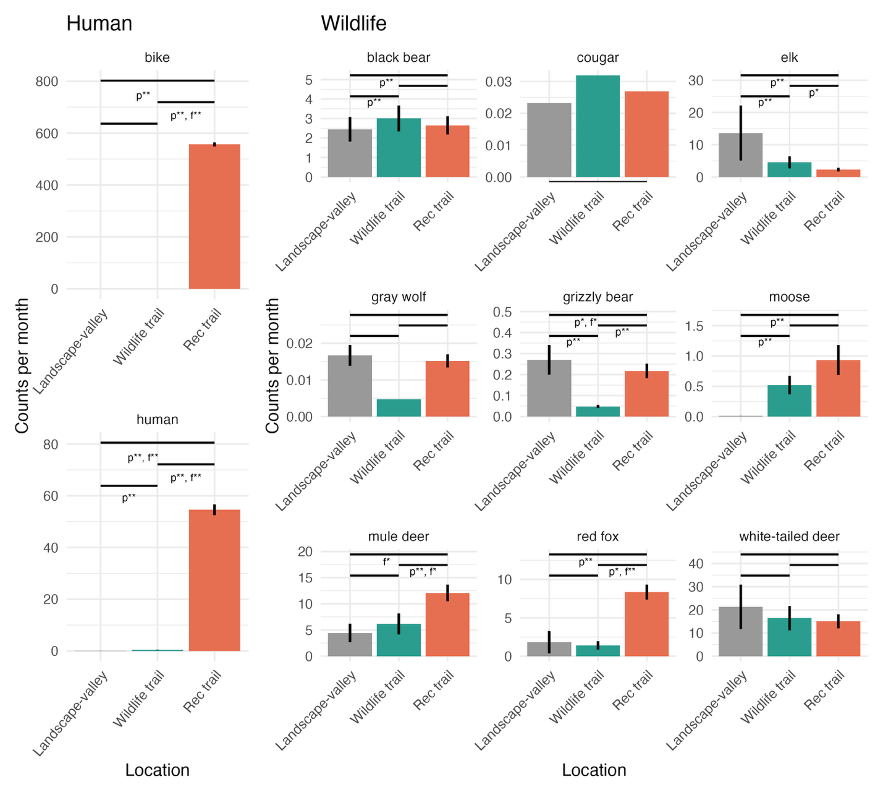

Figure 2. Intensity of use (monthly detection rate) assessments for human and wildlife groups across three zones. Results are predictions from a GLMM, and statistical significance shown as * for p<0.1 and ** for p<0.05 for presence (p) and detection frequency (f) under the applicable bar. Horizontal Bars indicate comparison between groups. The horizontal bar spanning the full width is a combined comparison between landscape-valley and the Mt Fernie trail network (i.e., wildlife and recreation trails pooled). Cougar and gray wolf did not have sufficient detections for model convergence and were excluded from subsequent analyses.

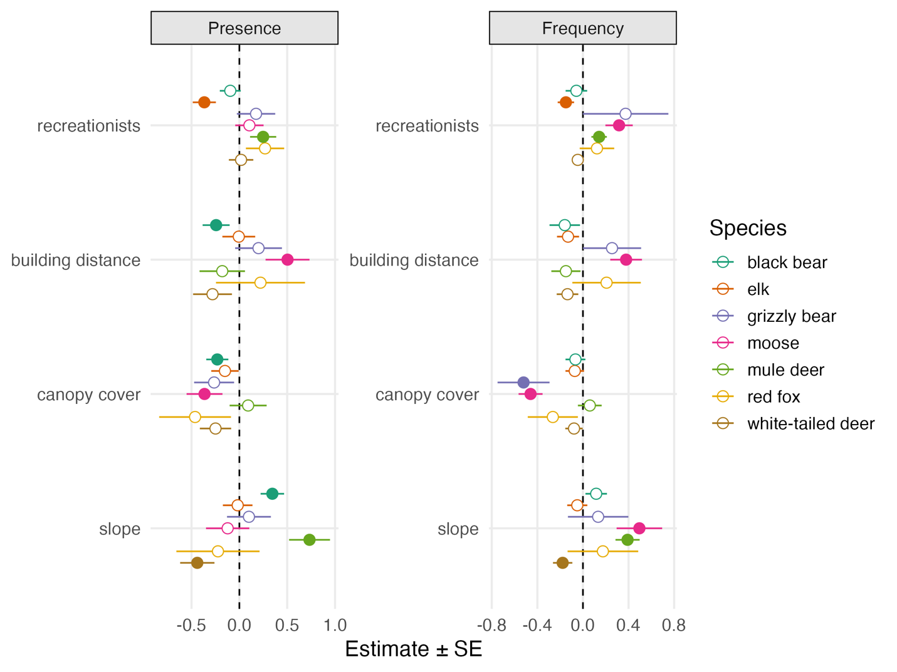

Figure 3. Influence of the number of recreationists on wildlife detections by species on recreation trails in the Fernie trail network. Ancillary habitat variables included to control for additional variation and compare magnitude of response. Filled dots signify statistical significance at p<0.1.

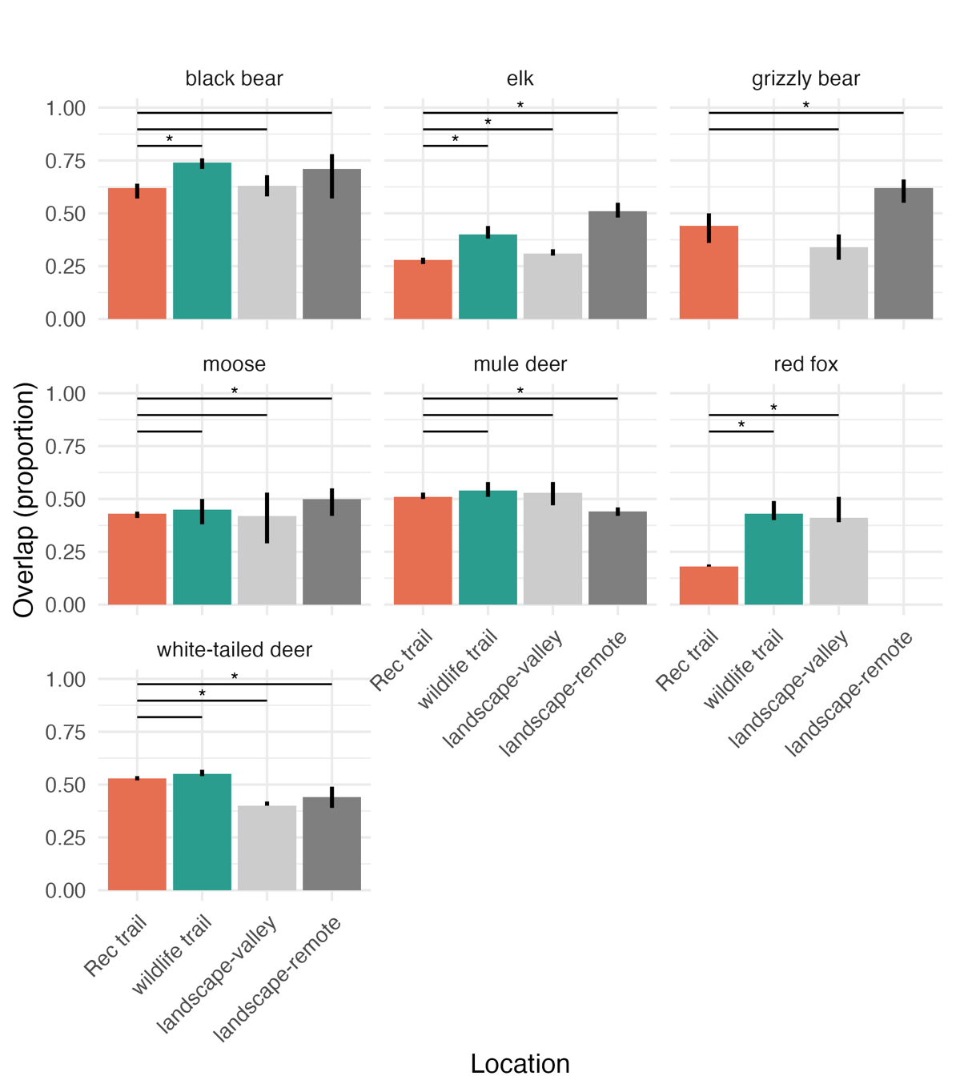

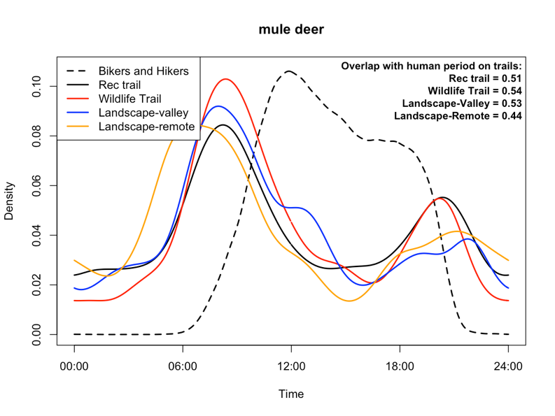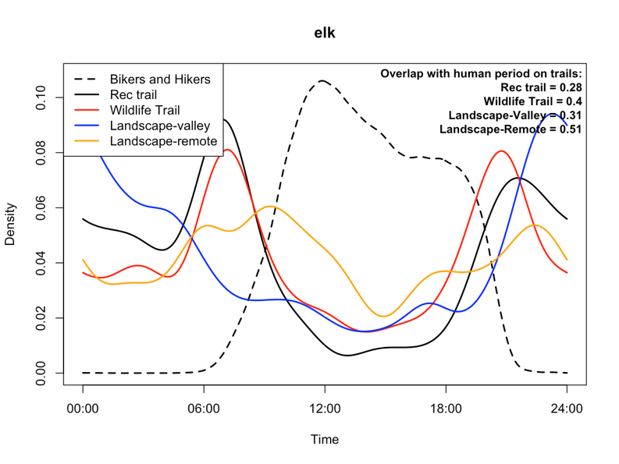

Figure 4. top left) Comparison of recreation, wildlife, and larger landscape diel patterns for mule deer which show little diel changes across habitat context, top right) Comparison of recreation, wildlife, and larger landscape diel patterns for elk that show more daytime activity in remote areas, bottom) average overlap with peak recreation time from recreation trails between trail types for all species and areas. Horizontal bars and asterisks indicate if overlap at other location are statistically different than those observed on recreation trails. Statistical significance shown as * for p<0.1.

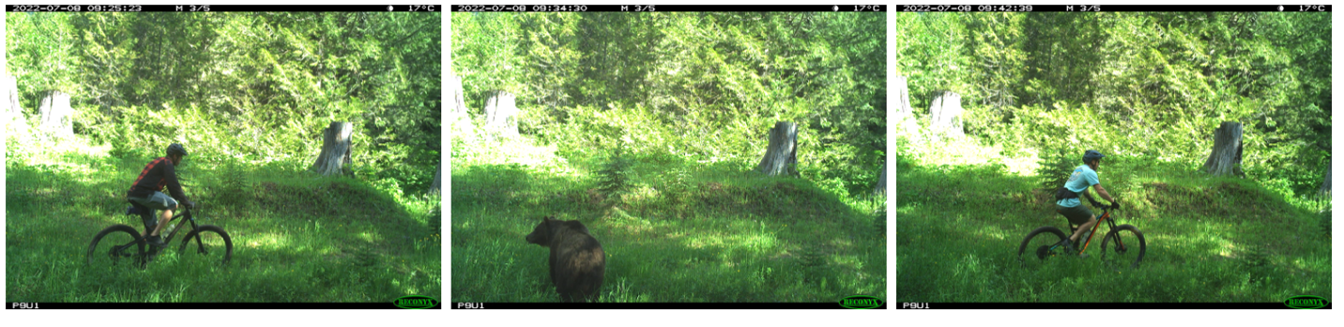

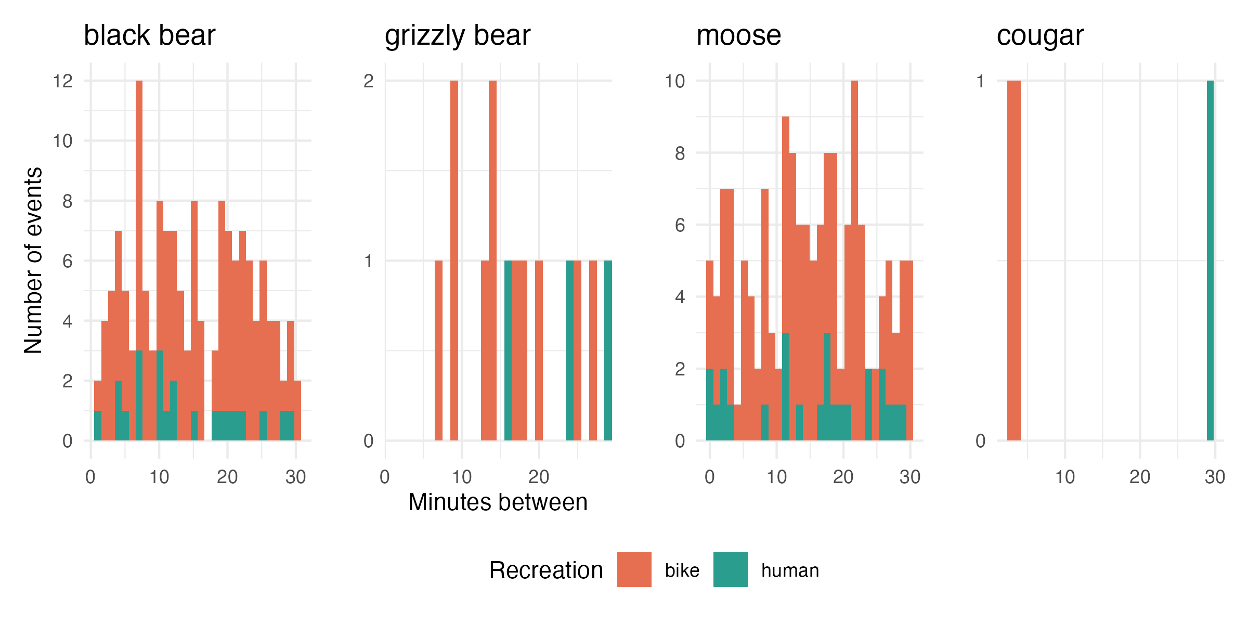

Figure 5. Near encounters between recreationists and three species of wildlife that can be dangerous to people. top) Example sequence showing bikers detected 2 minutes before and 5 minutes after a black bear on a single-track trail, and bottom) histogram of minutes between recreationists and select wildlife species between 2021-2024.

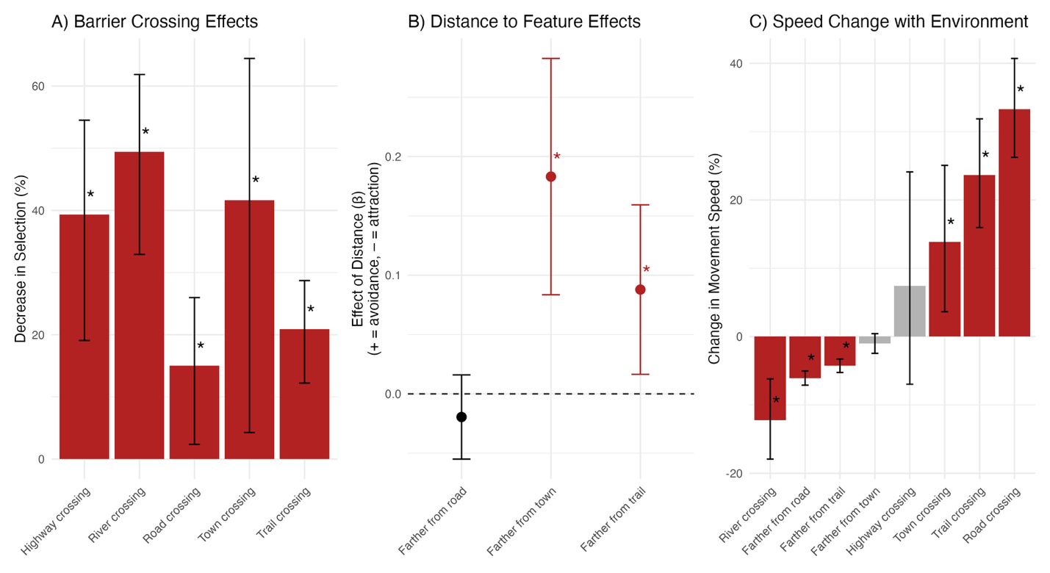

Figure 6. Integrated step selection results for grizzly bears near Fernie, BC. Response to human features shown A)decrease in selection for crossing various human features, B) effect of distance to human features. Note highway not included here due to covariance with distance to town, and C) change in movement speed in various contexts.



Figure 7. Educational signage created by the Fernie Trails Alliance using findings from this study. The signs were installed at high-use trailheads to communicate evidence-informed actions that recreationists can take to help minimize disturbance to wildlife. This example highlights an effective research-to-practice pathway and the value of working with recreation organizations to enhance outreach and adoption of wildlife-supportive measures. Non-stylized version of these activity patterns shown in Supplementary Data S3.

Table 2. Summary of recreation effects across scales and species.

|  |  |  |  |  |  |
| --- | --- | --- | --- | --- | --- |
| **Selection Order** | **3rd** | | | **4th** |  |
| **Species** | *Response to trail network at landscape scale* | *Fine scale use of trails vs nearby wildlife trail* | *Use of single-track trails with increasing recreational pressure* | *diel patterns on trails when people are active* | **Overall recreation effect** |
| Black bear | selection | neutral | neutral | avoidance | Landscape selection, fine scale avoidance/coexistence |
| Elk | avoidance | avoidance | avoidance | avoidance | Landscape avoidance, fine scale avoidance |
| Grizzly bear | avoidance | selection | neutral | avoidance | Landscape avoidance, fine scale coexistence |
| Moose | selection | neutral | selection | avoidance | Landscape selection, fine scale coexistence |
| Mule deer | selection | selection | selection | neutral | Landscape selection, fine scale coexistence |
| Red fox | selection | selection | neutral | avoidance | Landscape selection, fine scale coexistence |
| White-tailed deer | neutral | neutral | neutral | selection | Landscape neutral, fine scale coexistence |

**Discussion**

Our study revealed that large mammal responses to non-motorized recreation in the Southern Canadian Rockies varied considerably among species, spatial scales, and behavioral metrics. Elk and grizzly bears showed avoidance of recreation at landscape and trail scales, whereas black bear, moose, mule deer, white-tailed deer, and red fox exhibited tolerance or behavioral adaptations such as diel shifts in activity. The goal of our study was to add to the growing body of literature on wildlife responses to recreational pressure and provide wildlife managers with locally relevant information to inform decisions, given previous research documented substantial species and context-specific responses to recreation (e.g., Naidoo and Burton (2020), Miller et al. (2020), Procko et al. (2022), Granados et al. (2023), Jordan et al. (2025), Boone et al. (2024), and Anderson et al. (2023)).

Overall, our hypothesis of strong and negative responses to recreation across species was rejected. Instead, and perhaps inconvenient for management, we observed variable and scale-dependent responses in several species. Elk, for example, exhibited avoidance of recreational areas at both broad (third order) and fine (fourth order) scales, suggesting that recreation may displace individuals from otherwise suitable habitat. Grizzly bears showed moderate landscape-scale avoidance of trail networks in GPS and camera data but appeared to select for recreational trails rather than wildlife trails as travel corridors when moving through the trail network. Recreation trails are well maintained linear corridors that bears may be able to move through easier than wildlife trails. In contrast, red foxes did not show strong spatial avoidance but shifted their activity patterns to avoid humans temporally. It is likely that landscape-scale avoidance may be more indicative of demographic consequences such as reduced abundance due to a functional loss of habitat, whereas diel behavioral shifts may reflect a more flexible, potentially less costly coexistence strategy. However more work assessing the overall demographic consequences of these behavioural shifts would be valuable to fully understand recreation effects on wildlife populations.

The variation in responses among species likely reflects both intrinsic traits, such as body size, trophic position, and anti-predator strategies, and extrinsic factors including recreation intensity, trail design, and predictability of human presence. Conceptual frameworks such as the “landscape of fear” (Brown et al. 1999), “risk-disturbance hypothesis” (Frid and Dill 2002), and the “human shield hypothesis” (Berger 2007) have been proposed to explain these patterns. The landscape of fear framework suggests that animals perceive and respond to spatial variation in predation risk, often avoiding areas they associate with danger—even if those areas contain valuable resources (Brown et al. 1999). Building on this, the risk-disturbance hypothesis posits that wildlife treat human disturbance as a form of predation risk, leading to anti-predator behaviors such as avoidance, increased vigilance, or altered activity patterns in areas used by people (Frid and Dill 2002). Because some wildlife avoid people, the human shield hypothesis proposes that some prey species may benefit from human presence by using areas near people as refuges from natural predators, who themselves avoid humans (Berger 2007). Empirical results provide mixed support for these hypotheses in explaining the variation among species and scales in response to recreation. Multi-species analyses often show some species had positive responses to recreation (Naidoo and Burton 2020, Procko et al. 2022, Fennell et al. 2023, Granados et al. 2023), suggesting the risk-disturbance hypothesis does not explain recreation effects as whole. Support for the landscape of fear and human shield also remain mixed with cases of predator and prey selecting for recreation trails (Granados et al. 2023), but others showing some support for avoidance of recreation trails by large predators and selection by prey (Procko et al. 2022, Fennell et al. 2023).

Our findings provide additional insights. Prey species showed mixed responses to recreation with clear avoidance of recreation by elk and selection for recreation by mule deer and moose, suggesting that there is not widespread support for the landscape of fear or risk-disturbance hypotheses. We had limited data to fully assess the human shield hypothesis, however the one large predator that we had sufficient data, the grizzly bear, did appear to avoid the area due to recreation pressure. Limited data on cougar and wolves reduced our ability to assess the response of the full large predator community but the anectodical evidence we had showed cougars were detected at similar levels within the trail network compared to the surrounding landscape, but perhaps some avoidance of the area by wolves. Regardless, because the primary prey of these large carnivores did not show consistent selection or avoidance of the area the human shield hypothesis is not an explanation for the responses of all species in the Fernie trail network.

The response of elk to recreation was among the most consistent and negative of all species in our study. Elk were significantly less likely to occur within the trail network compared to the broader landscape, and within the trail network, they were less likely to use recreational trails than adjacent off-trail areas. When using recreation trails, elk were more likely to use trails with fewer recreational users—the only species with this response. These multiple lines of evidence suggest that recreation may displace elk from otherwise suitable habitat, consistent with other studies showing elk sensitivity to human activity (e.g., Anderson et al. 2023, Procko et al. 2024, Jordan et al. 2025, Peters et al. 2025). Elk avoided daytime periods on recreation trails more strongly than they did on wildlife trails within the Fernie network or at remote site. However, elk generally had low use of daytime periods on recreational trails, wildlife trails, and the landscape-valley cameras compared to landscape-remote cameras suggesting the avoidance of daytime on the recreation trails may not solely be due to recreation effects and may be a response to additional human pressures such as towns, roads, or hunting pressure. Supporting this idea, Peters et al. (2025) documented strong avoidance responses of a European elk species (red deer) to hunting pressure, which amplified avoidance of recreational pressures.

Overall the strong response of elk to recreation in our study and others seems to juxtapose with concurrent observations of elk becoming a nuisance in human-dominated areas such as agricultural fields and even in towns (Wilmers and Levi 2013, Guthrie 2020, Rutherford et al. 2025). Resolving this juxtaposition was not a focus of our study but clearly demonstrates the multiple competing pressures that elk are responding to in a multi-use landscape. In the case of agricultural conflicts, the reduced prevalence of hunters and predators on working ranches paired with productive forage results in dense congregations of elk. Clearly human presence thus does not always produce negative responses in elk. Elk can be found in great numbers near people when human presence is tied to productive habitat and mortality reduction. There are other examples where elk congregate near people and disturbance such as open pit coal mines in the Elk Valley where hunters and predators are rare and patches of reclaimed areas can temporarily provide nutrient dense food (Poole et al. 2024). Indeed elk do appear to show a functional response in selection for human footprint that depends on the level of human footprint they are continually exposed to suggesting habituation and synanthropy (Gaynor et al. 2025). Elk likely avoid recreation trails because the trade-off of disturbance from recreationists was not offset by sufficient benefits such as better forage and there was insufficient predator or hunter avoidance of these areas. One prediction from this would be that if recreational use was more intense in the Fernie trail network, and as a result predators had stronger avoidance of the area, and forage was increased through habitat restoration, then elk may have neutral or positive responses to recreation. Such a prediction would require testing, and the increased recreational intensity would continue to come with trade-offs for other wildlife species and recreationists.

Grizzly bears displayed a complex response to non-motorized recreation. At a broad scale, GPS data indicated moderate avoidance of the Mt. Fernie trail network relative to the surrounding valley landscape. Within the network, however, camera data showed grizzly bears were more likely to use recreation trails than adjacent wildlife trails, but overall, the use of the trails within the Mt Fernie network (wildlife and recreation trails) was lower than the surrounding landscape. This apparent selection for recreation trails compared to wildlife trails within the trail network may reflect efficient travel along predictable corridors, which is consistent with the step selection analysis that shows bears moving faster when using the trail network. The overall low detection rates within the trail network and moderate avoidance of high-use zones suggest that trail use by grizzly bears is limited to periods or areas with lower human activity. This dual pattern of broad-scale avoidance and localized, functional trail use is consistent with a risk-management strategy in which bears minimize overlap with people while exploiting the linear features for movement when safe to do so. Similar to elk, grizzly bears were more nocturnal within the Fernie trail network and landscape-valley trails than the landscape-remote cameras suggesting human effects beyond just recreation are causing bears to alter their behaviour. The iSSA analysis provides important context of bears’ response to other competing human pressures. While bears avoided the trail network, they more strongly avoided settled areas such as the area around the city of Fernie, thus the effects detected from cameras within the Fernie trail network must be considered with cumulative effects of additional pressures of the town, highway, and roads in mind. Bears avoided crossing the recreation trails and resource roads, but not nearly as much as they avoided crossing the town, or highway.

From a management perspective, our results indicated that non-motorized recreation can influence wildlife habitat use and behavior, but effects were species- and context-specific. It is our perspective that overall, the behavioural effects of recreation were moderate to low for the species we considered, especially considering the currently compact footprint of the trail network relative to the surrounding landscape. Of the species considered, elk and grizzly bear were the primary species that showed negative effects, with elk showing the most consistent and strong responses. Mitigating the negative effects to elk and grizzly bear could be accomplished by concentrating recreation in high-use, predictable areas such as those around existing towns. Such an approach reduces the spatial extent of disturbance because the towns themselves already have a buffer of impacts around them and provides low use refugia for more sensitive species in the areas outside the concentrated recreation areas. Seasonal or spatial closures may be warranted in areas that overlap with key habitats or during vulnerable periods such as bighorn sheep lambing areas or bear dens (Wiedmann and Bleich 2014). To protect the nocturnal and crepuscular periods that wildlife often begin to use as pressure increases during the day it is recommended to concentrate recreation pressure during the summer daylight hours between 9 am and 7 pm. The very low rate of near encounters between recreationists and wildlife, particularly large carnivores, suggests that current patterns of recreation do not pose a high risk of conflict, though proactive measures such as signage, concentrating use during the day, and education remain important to keep people safe (Figure 7). Wildlife in the Fernie trail network frequently adjust their behaviour to minimize interactions with recreationists, likely as a means of reducing risk. Given that animals are modifying their behaviour to coexist with human use, it is equally important that recreationists do what they can to coexist with wildlife.

Science can’t necessarily tell us whether moderate avoidance of the trail network by potentially dangerous species such as grizzly bears is a good or bad thing, that’s a value decision with many factors. The avoidance is negative in that it means grizzly bears functionally lose habitat, but because the intense recreation footprint is fairly constrained and within a disturbance buffer around Fernie, the effects are not large at the landscape scale. From a human and bear safety perspective the avoidance of an area where thousands of people recreate daily is likely positive due to reduced conflicts and risk to both parties. Grizzly bears choosing to use this area at night and generally avoiding it is good for recreationists. The negative effects to grizzly populations could be more pronounced if the footprint of extensive recreation was much larger.

Although it is well documented that time in nature is good for people, the effects of recreation on wildlife continues to be an evolving area of research that struggles to find consistently strong effects across contexts and species. There is substantial variation in the perspectives of the public and recreationists on the effects of recreation on wildlife, which ranges from benign to substantial impacts. Recreationists commonly perceive any negative environmental impacts as the fault of other recreation types and rarely their preferred type of recreation (i.e., hikers blame mountain bikers and horseback riders, and vice versa, (Taylor and Knight 2003)). In a landscape of murky results, polarized stakeholders, and increasing recreational pressure, landscape managers are clearly left in a challenging position. Some of the challenge in finding consistent effects of recreation may be a result of layers of ecological complexity that result in true context-dependency or could be a result of generally small true effect sizes and confounding variables creating variable results.

Our study relied on observational data, which limits our ability to infer causality. Although we used a multi-scale design and integrated camera and GPS data, confounding factors such as habitat quality, habituation, topography, and detectability cannot be fully controlled in a non-experimental setting. A second limitation stems from differences in sampling design: cameras in the Mt. Fernie trail network were deployed at high density along established trails, whereas Landscape-valley cameras were distributed across a much larger and more heterogeneous area. Even with standardized detection rates and the inclusion of environmental covariates and random effects, these design differences may influence detectability and reduce the comparability of results across scales. As a result, our analysis speaks most directly to a specific management question—how increasing recreation within an already human-influenced, multi-use landscape affects wildlife behaviour—rather than how new recreation would affect wildlife in undeveloped or roadless areas.

As noted by others (e.g., Jordan et al. 2025), stronger inference requires experimental approaches, such as Before-After-Control-Impact (BACI) designs, temporary trail closures, or controlled recreation manipulations. Although such studies present logistical and ethical challenges, they are critical for establishing causal links between recreation and wildlife responses and for identifying thresholds of acceptable use. Indeed the “anthropause” during the COVID-19 pandemic and other management interventions have provided natural experiments that researchers have exploited to gain stronger inference (Procko et al. 2022, Anderson et al. 2023, Boone et al. 2024, Naidoo et al. 2025). We encourage land managers, trail alliances, and researchers to collaborate and set up BACI experiments prior to new trails being built. Such experiments would ideally have multiple years of before and after data and include measurements directly on the trail and nearby within the buffer of potential recreation effects (100-500 m). A BACI approach would provide strong evidence of the effect of recreation on wildlife. Replicating these experiments across gradients of recreation disturbance such as new trails within existing networks and those within less disturbed landscapes, as well as across differing recreation use volumes would eventually provide the critical information to assess the context-dependent nature of recreation.

**Acknowledgements**

This study was made possible due to financial support from the Liber Ero Fellowship, British Columbia Conservation Trust Foundation, TC Energy, and the Wilburforce Foundation. Thanks to Melanie Dickie for providing feedback on an earlier version of the manuscript. Thanks to Melanie Dickie of the Alberta Biodiversity Monitoring Institute and Melanie Wrigglesworth of the Fernie Trails Alliance for comments on an earlier version of this paper. Thanks to Troy Malish and Todd Penke for support checking these cameras. Thanks to the Alberta Biodiversity Monitoring Institute for their support classifying all our images.

**Supplementary Data**

Supplementary Data S1.—Moran’s I tests for spatial autocorrelation

Table SD1. Moran’s test results for each species spatial autocorrelation assessment using monthly detection rates.

|  |  |  |  |
| --- | --- | --- | --- |
| species | statistic | estimate | p |
| black bear | 1.09161568 | 0.00113999 | 0.13750103 |
| elk | 4.48388769 | 0.01132731 | 0.00000366 |
| grizzly bear | 0.25475715 | -0.0063893 | 0.39945534 |
| moose | -0.1274164 | -0.0046339 | 0.55069459 |
| mule deer | -2.4129532 | -0.012089 | 0.99208808 |
| red fox | -0.492696 | -0.009002 | 0.68888631 |
| white-tailed deer | -1.9277434 | -0.0058884 | 0.97305647 |
| gray wolf | -0.3369542 | -0.0494261 | 0.6319243 |
| cougar | 0.6879606 | -0.0108369 | 0.2457388 |

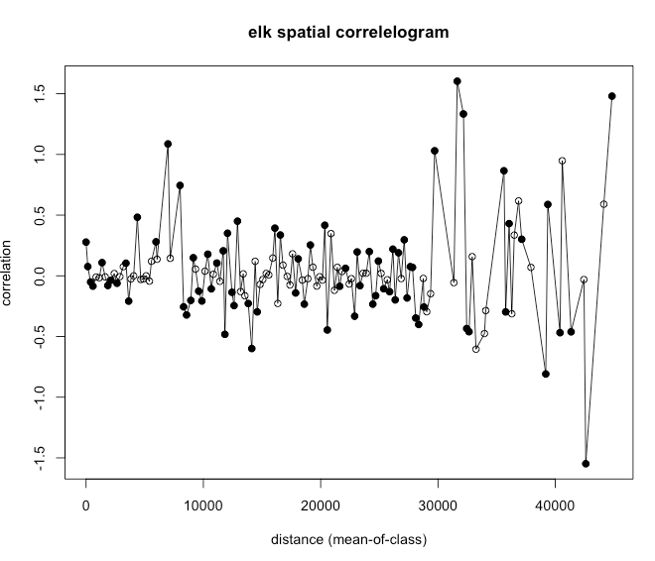

Figure SD1. Spatial correlelogram for elk, which had a significant, but biologically small, spatial autocorrelation result from the Moran’s I test.

Supplementary Data S2.—Results of overdispersion tests

Table SD2. Results of overdispersion tests

|  |  |  |
| --- | --- | --- |
| species | dispersion | p |
| black bear | 1.60004886 | 0.056 |
| elk | 2.67395032 | 0.152 |
| grizzly bear | 1.24386885 | 0.464 |
| moose | 1.79703833 | 0.168 |
| mule deer | 0.07679609 | 0.352 |
| red fox | 1.39174379 | 0.344 |
| white-tailed deer | 1.62559995 | 0.344 |
| gray wolf | 1.13333659 | 0.624 |
| cougar | 0.9370501 | 1 |

Supplementary Data S3.—Wildlife diel activity on recreation trails within the Mt. Fernie Trail Network

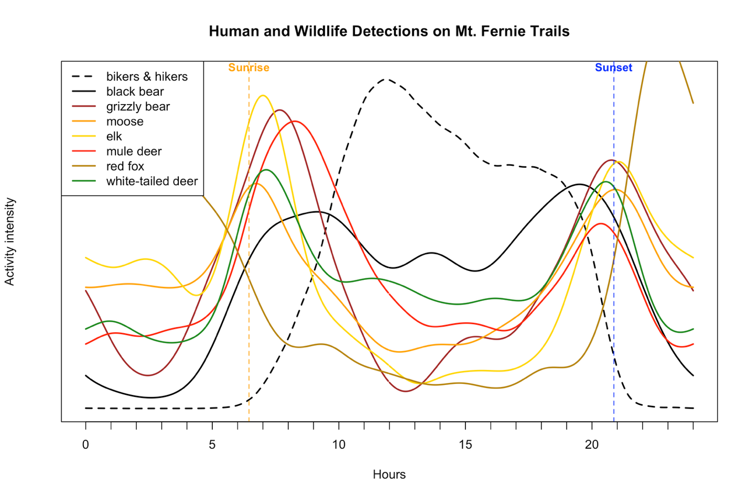

*Figure SD3. Diel patterns of wildlife and human recreation on recreation trails in the Fernie trail network.*

**References**

Akaike, H. 1973. Information theory and an extension of the maximum likelihood principle. Budapest, Hungary.

Anderson, A. K., J. S. Waller, and D. H. Thornton. 2023. Partial COVID-19 closure of a national park reveals negative influence of low-impact recreation on wildlife spatiotemporal ecology. Scientific Reports 13:687.

Apps, C. D., B. N. McLELLAN, J. G. Woods, and M. F. Proctor. 2004. ESTIMATING GRIZZLY BEAR DISTRIBUTION AND ABUNDANCE RELATIVE TO HABITAT AND HUMAN INFLUENCE. Journal of Wildlife Management 68:138–152.

Avgar, T., J. R. Potts, M. A. Lewis, and M. S. Boyce. 2016. Integrated step selection analysis: bridging the gap between resource selection and animal movement. Methods in Ecology and Evolution 7:619–630.

Beery, S., D. Morris, and S. Yang. 2019, July 15. Efficient Pipeline for Camera Trap Image Review. arXiv.

Berger, J. 2007. Fear, human shields and the redistribution of prey and predators in protected areas. Biology Letters 3:620–623.

Bivand, R. 2022. R Packages for Analyzing Spatial Data: A Comparative Case Study with Areal Data. Geographical Analysis 54:488–518.

Boone, H. M., M. Romanski, K. Kellner, R. Kays, L. Potvin, G. Roloff, and J. L. Belant. 2024. Recreational trail use alters mammal diel and space use during and after COVID-19 restrictions in a U.S. national park. Global Ecology and Conservation:e03363.

Bratman, G. N., C. B. Anderson, M. G. Berman, B. Cochran, S. de Vries, J. Flanders, C. Folke, H. Frumkin, J. J. Gross, T. Hartig, P. H. Kahn, M. Kuo, J. J. Lawler, P. S. Levin, T. Lindahl, A. Meyer-Lindenberg, R. Mitchell, Z. Ouyang, J. Roe, L. Scarlett, J. R. Smith, M. van den Bosch, B. W. Wheeler, M. P. White, H. Zheng, and G. C. Daily. 2019. Nature and mental health: An ecosystem service perspective. Science Advances 5:eaax0903.

Breck, S. W., S. A. Poessel, P. Mahoney, and J. K. Young. 2019. The intrepid urban coyote: a comparison of bold and exploratory behavior in coyotes from urban and rural environments. Scientific Reports 9:2104.

Brooks, M. E., K. Kristensen, K. J. van Benthem, A. Magnusson, C. W. Berg, A. Nielsen, H. J. Skaug, M. Mächler, and B. M. Bolker. 2017. glmmTMB Balances Speed and Flexibility Among Packages for Zero-inflated Generalized Linear Mixed Modeling. The R Journal 9:378–400.

Brown, J. S., J. W. Laundré, and M. Gurung. 1999. The Ecology of Fear: Optimal Foraging, Game Theory, and Trophic Interactions. Journal of Mammalogy 80:385–399.

Ciarniello, L. M., M. S. Boyce, D. R. Seip, and D. C. Heard. 2007. Grizzly Bear Habitat Selection Is Scale Dependent. Ecological Applications 17:1424–1440.

Costello, C. M., S. I. Cain, R. M. Nielson, C. Servheen, and C. C. Schwartz. 2013. Response of American black bears to the non-motorized expansion of a road corridor in Grand Teton National Park. Ursus 24:54–69.

Fennell, M., C. Beirne, and A. C. Burton. 2022. Use of object detection in camera trap image identification: Assessing a method to rapidly and accurately classify human and animal detections for research and application in recreation ecology. Global Ecology and Conservation 35:e02104.

Fennell, M. J. E., A. T. Ford, T. G. Martin, and A. C. Burton. 2023. Assessing the impacts of recreation on the spatial and temporal activity of mammals in an isolated alpine protected area. Ecology and Evolution 13:e10733.

Forman, R. T. T., and L. E. Alexander. 1998. Roads and Their Major Ecological Effects. Annual Review of Ecology and Systematics 2:207-231+C2.

Frid, A., and L. M. Dill. 2002. Human-caused Disturbance Stimuli as a Form of Predation Risk. Conservation Ecology 6:art11.

Gaynor, K. M., F. P. Hayes, K. Manlove, N. Galloway, J. F. Benson, M. J. Cherry, C. W. Epps, R. J. Fletcher Jr, J. Orrock, J. A. Smith, C. Aiello, J. L. Belant, J. Berger, M. Biel, J. Bright, J. Bump, M. Burchett, C. Butler, J. Carlson, E. K. Cole, N. Darby, E. Degutis, S. Dewey, P. Figura, T. D. Gable, J. Gagnon, D. M. Glass, J. R. Green, K. Gunther, M. A. Haroldson, K. R. Hersey, B. P. Holton, A. T. Homkes, S. R. Hoy, D. Hughson, K. Joly, R. Leahy, C. Lee-Roney, R. Lester, D. MacNulty, M. Magnuson, D. Martin, R. Mazur, S. Moore, E. K. Orning, K. Patrick, R. O. Peterson, L. Potvin, P. R. Prentice, S. P. D. Riley, M. C. Romanski, A. Roug, J. A. Sikich, N. Simpson, W. Sloan, D. W. Smith, M. Sorum, S. Sprague, D. Stahler, J. Stephenson, T. R. Stephenson, J. Stroud-Settles, F. T. van Manen, J. A. Vucetich, K. Wilmot, S. Windels, T. M. Wolf, and P. C. Cross. 2025. The influence of human presence and footprint on animal space use in US national parks. Proceedings of the Royal Society B: Biological Sciences 292:20251013.

Gaynor, K. M., C. E. Hojnowski, N. H. Carter, and J. S. Brashares. 2018. The influence of human disturbance on wildlife nocturnality. Science 360:1232–1235.

Granados, A., C. Sun, J. T. Fisher, A. Ladle, K. Dawe, C. Beirne, M. S. Boyce, E. Chow, N. Heim, M. Fennell, J. Klees van Bommel, R. Naidoo, M. Procko, F. E. C. Stewart, and A. C. Burton. 2023. Mammalian predator and prey responses to recreation and land use across multiple scales provide limited support for the human shield hypothesis. Ecology and Evolution 13:e10464.

Guthrie, J. W. 2020. Understanding and Preventing Elk Use of Agriculture Crops. M.S., University of Idaho, United States -- Idaho.

Hartig, F. 2024. DHARMa: Residual Diagnostics for Hierarchical (Multi-Level / Mixed) Regression Models.

Johnson, D. H. 1980. The Comparison of Usage and Availability Measurements for Evaluating Resource Preference. Ecology 61:65–71.

Jordan, S. E., T. R. Ganz, T. K. Rutherford, M. J. Blocker, C. T. Domschke, F. L. Klasner, E. H. Masters, T. A. Morgan, D. R. Ratajczak, E. C. Teige, and S. K. Carter. 2025. Effects of nonmotorized recreation on ungulates in the western United States—A science synthesis to inform National Environmental Policy Act analyses. US Geological Survey.

Laliberte, A. S., and W. J. Ripple. 2004. Range Contractions of North American Carnivores and Ungulates. BioScience 54:123.

Lamb, C. 2025a. Flathead and Elk Valley Mountain Pass Monitoring: Year 2. Page 44. Yaq?it ?a·knuq?i ’it and the Province of British Columbia, East Kootenay, BC.

Lamb, C., E. Chow, and M. Jones. 2025. Reconnecting the Rockies:BC 2020-2024 Progress Report. Page 61. British Columbia Ministry of Transportation and Transit.

Lamb, C., L. Smit, B. McLellan, L. M. Vander Vennen, and M. Proctor. 2022. Considerations for furbearer trapping regulations to prevent grizzly bear toe amputation and injury. Wildlife Society Bulletin 46:e1343.

Lamb, C. T. 2025b. Tourism Fernie Recreation Monitoring of Heiko’s Trail: 2024 Progress Report. Page 48. Tourism Fernie.

Lamb, C. T., A. T. Ford, B. N. McLellan, M. F. Proctor, G. Mowat, L. Ciarniello, S. E. Nielsen, and S. Boutin. 2020. The ecology of human–carnivore coexistence. Proceedings of the National Academy of Sciences 117:17876–17883.

Lamb, C. T., L. Smit, G. Mowat, B. McLellan, and M. Proctor. 2023. Unsecured attractants, collisions, and high mortality strain coexistence between grizzly bears and people in the Elk Valley, southeast British Columbia. Conservation Science and Practice 5:e13012.

Miller, A. B., R. Kays, and Y.-F. Leung. 2020. Wildlife response to recreational trail building: An experimental method and Appalachian case study. Journal for Nature Conservation 56:125815.

Monz, C. A., C. M. Pickering, and W. L. Hadwen. 2013. Recent advances in recreation ecology and the implications of different relationships between recreation use and ecological impacts. Frontiers in Ecology and the Environment 11:441–446.

Muff, S., J. Signer, and J. Fieberg. 2020. Accounting for individual-specific variation in habitat-selection studies: Efficient estimation of mixed-effects models using Bayesian or frequentist computation. Journal of Animal Ecology 89:80–92.

Naidoo, R., and A. C. Burton. 2020. Relative effects of recreational activities on a temperate terrestrial wildlife assemblage. Conservation Science and Practice 2:e271.

Naidoo, R., S. Gulati, J. Vercammen, and C. Burton. 2025. Estimating Causal Impacts of Human Recreation on Wildlife in the Absence of Experimental Controls. Conservation Letters 18:e13140.

Naylor, L. M., M. J. Wisdom, and R. G. Anthony. 2009. Behavioral Responses of North American Elk to Recreational Activity. Journal of Wildlife Management 73:328–338.

Outdoor Foundation. 2025. 2025 OUTDOOR PARTICIPATION TRENDS REPORT. Page 83. Outdoor Industry Association, Boulder, CO.

Palm, E. C., T. Avgar, M. Dickie, B. N. McLellan, J. M. Northrup, M. A. Sawaya, J. W. Turner, J. Whittington, E. L. Landguth, K. A. Zeller, and C. T. Lamb. 2024. Movement models reveal changing grizzly bear habitat use and functional connectivity in response to human disturbance in the southern Canadian Rocky Mountains. Conservation Science and Practice.

Peters, A., A. F. Smith, M. Henrich, C. F. Dormann, and M. Heurich. 2025. Temporal displacement of the mammal community in a protected area due to hunting and recreational activities. Ecological Applications 35:e70118.

Poole, K. G., C. T. Lamb, S. Medcalf, and L. Amos. 2024. Migration, movements, and survival in a partially migratory elk (Cervus canadensis) population. Conservation Science and Practice n/a:e13128.

Procko, M., R. Naidoo, V. LeMay, and A. C. Burton. 2022. Human impacts on mammals in and around a protected area before, during, and after COVID ‐19 lockdowns. Conservation Science and Practice 4.

Procko, M., S. G. Winder, S. A. Wood, M. Sevigny, D. G. Collins, M. Alves, and L. R. Prugh. 2024. Quantifying impacts of recreation on elk (Cervus canadensis) using novel modeling approaches. Ecosphere 15:e4873.

Prokopenko, C. M., M. S. Boyce, and T. Avgar. 2017. Extent-dependent habitat selection in a migratory large herbivore: road avoidance across scales. Landscape Ecology 32:313–325.

Rutherford, K., D. Visscher, and C. C. S. Clair. 2025. Jurisdictional scan of strategies for mitigating elk-agriculture conflict. University of Alberta, Edmonton, Alta.

Taylor, A. R., and R. L. Knight. 2003. Wildlife Responses to Recreation and Associated Visitor Perceptions. Ecological Applications 13:951–963.

Thompson, P. R., J. Paczkowski, J. Whittington, and C. C. St. Clair. 2024. Integrating human trail use in montane landscapes reveals larger zones of human influence for wary carnivores. Journal of Applied Ecology n/a.

Thomsen, J. M., R. B. Powell, and C. Monz. 2018. A Systematic Review of the Physical and Mental Health Benefits of Wildland Recreation. Journal of Park and Recreation Administration 36:123–148.

Tucker, M. A., L. Santini, C. Carbone, and T. Mueller. 2021. Mammal population densities at a global scale are higher in human-modified areas. Ecography 44:1–13.

Urhan, U., K. Platjouw, P. P. de Vries, E. Serrano Davies, and K. van Oers. 2025. Associations between human non-motorised recreational activity on nest box occupation, exploratory behaviour and breeding success in a passerine bird. Journal of Avian Biology 2025:e03281.

Whittington, J., M. Hebblewhite, R. W. Baron, A. T. Ford, and J. Paczkowski. 2022. Towns and trails drive carnivore movement behaviour, resource selection, and connectivity. Movement Ecology 10:17.

Wiedmann, B. P., and V. C. Bleich. 2014. Demographic responses of bighorn sheep to recreational activities: A trial of a trail: Bighorn Sheep Responses to Recreation. Wildlife Society Bulletin 38:773–782.

Wilmers, C. C., and T. Levi. 2013. Do irrigation and predator control reduce the productivity of migratory ungulate herds? Ecology 94:1264–1270.

Wisdom, M. J. 2005. The Starkey Project: a synthesis of long-term studies of elk and mule deer. Lawrence, Kansas: Alliance Communications Group. 252 p.

Wisdom, M. J., H. K. Preisler, L. M. Naylor, R. G. Anthony, B. K. Johnson, and M. M. Rowland. 2018. Elk responses to trail-based recreation on public forests. Forest Ecology and Management 411:223–233.

Wyckoff, T. B., H. Sawyer, S. E. Albeke, S. L. Garman, and M. J. Kauffman. 2018. Evaluating the influence of energy and residential development on the migratory behavior of mule deer. Ecosphere 9:e02113.